

GUJARAT TELECOM CIRCLE

AHMEDABAD

Broadband Equipment

Preventive Maintenance

Manual

Third Issue (July – 2011)

Issued By:

Broadband Cell,

Gujarat Telecom Circle,

C. G. Road, Ahmedabad.

I N D E X

Sr.  No. | Content | Page No.
1 | Preventive maintenance of P 2.2 system DSLAM | 3
1 | (A) Commands for Huawei make DSLAMs | 4
2 | Preventive maintenance of multiplay DSLAMs | 7
2 | (A) Commands for ZTE make DSLAMs | 8
2 | (B) Commands for UTstarcom make DSLAMs | 13
2 | (C) Commands for Nokia-Siemens make DSLAMs | 17
3 | ZTE OCLAN – Functional description of LEDs  in various cards | 21
4 | NMS / EMS of multiplay BB equipments  Netman-6000 OMC-O ( RPR NMS - UT )  Netman-4000 OMC-A ( DSLAM NMS - UT )  ZTE Netnumen ( DSLAM NMS –ZTE ) | 24
5 | DSL tester | 36
6 | (A) Broadband related important tips | 38
6 | (B) Broadband error codes & remedy | 44
6 | (C) Important vendor contact details | 45
7 | Call / RMA booking procedure | 49

Part – 1 : Preventive maintenance of HUAWEI DSLAMs

- Download Friendly Net Viewer and Prepare Virtual Network Diagram for all equipments of P 2.2 network of your SSA.
- Using Friendly Net Viewer monitor the T-2 Switches and DSLAMs of the SSA daily.
- Daily Checking the media link (Optical Fiber link) between DSLAM and T-2 and T-2 and T-1.
- Perform following checks at least on 10-15 DSLAMs everyday and take necessary action if any card / equipment is found faulty ( The screen shots and commands are given in subsequent pages).

  - Check the status of control card of DSLAM and T-2, T-1.
  - Check the status of all Fans in DSLAM.
  - Check the status of all cards of the DSLAM.
  - Check the status of chipset in DSLAM.
  - Check the status of all ports of each card in DSLAM and try to reset the hanged ports in DSLAM.

- Cleaning of DSLAM whenever required after concurrence with NIB/NOC.
- Docket booking for equipment / card related faults immediately and major faults which are not solved within reasonable time, at india.support@huawei.com and a copy of the fault docket may be sent to Bangalore NOC by mail to id bbnoc@dataone.in

The faulty card may be got replaced with a spare card if available immediately and faulty card must be sent to technical support centre of vendor along with the fault docket at following address:-

(A) Commands for Huawei make DSLAM

- To Check all the card status : Give command as show board 0

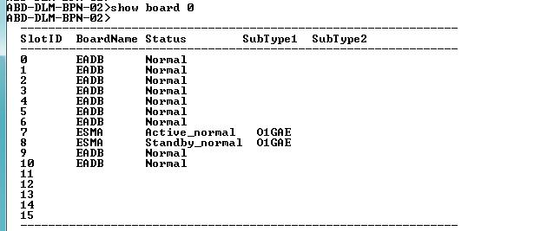
Control Cards
Normal /Healthy card

All cards should be in Normal status as given above. If any card (suppose 2) found faulty than give following commands.

  - ABD-DLM-GBT-01# config terminal
  - # board del 0/2
  - # board add 0/2 then give the name of card like EADA, EDB , EBDL
  - # adsl activate adsl 2/0/0 to adsl2/0/47 3 ( where 3 is profile name)

- Check all chipset status : Give command show adsl chipset status

All chipset should be in normal state. If it is faulty it has to be rectified.

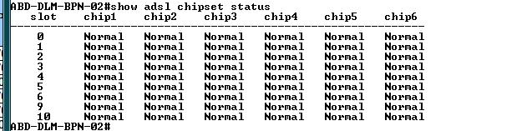
All chiset status must be Normal

If any chipset found faulty, give following commands to Reset the faulty chipset.
(Suppose chipset 3 of card no.1 is faulty than)

Dslam # config terminal
Dslam(confi) # board-adsl 1 ( To enter in card no. 1 , 1 is card no. )
Dslam(confi-board-adsl-1) # chipset reset 3 ( 3 is faulty chipset no. )

And then confirm the chipset status using above command.

- To check status of all Ports of DSLAM : Give command show adsl port state all.
All port should be in either active or activating state. If it is deactivate, it is faulty state.
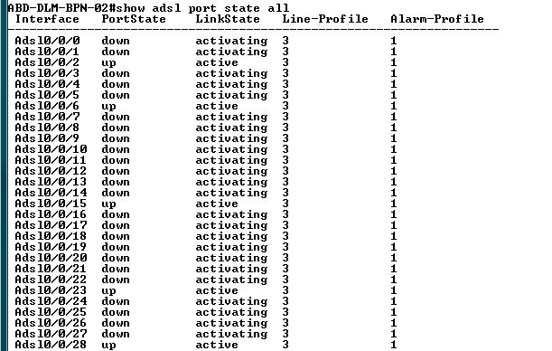
All ports must be
Active/Activating
Any port should not be
Deactivate

If port no. 0/0/24 is deactivate than

DSLAM(config) # adsl activate adsl 0/0/24 3 ( where 3 is profile)

- To check status of EMU ( Fan ) of DSLAM : Give command show emu
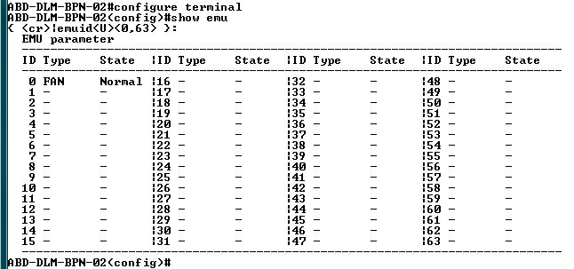

- To check status of Fan in 32 Port DSLAM : Give command show fan state
Fan status should be Normal



- To check status of Card & Ports in 32 Port DSLAM :

Give command show board 0/1
and show board 0/2
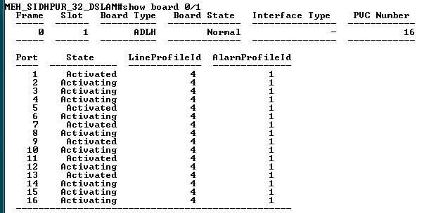

- To Reset faulty card of DSLAM : Give command

Dslam(confi) # board reset 0/2 ( Here 2 is faulty card no. )
Dslam(config)# board confirm 0/2

Part – 2 : Preventive maintenance of multiplay DSLAMs

- Download EMS/NMS for UT STAR and ZTE.
- Using EMS monitoring the RPR T-2 / T-1 and DSLAMs daily. ( Detailed procedure at page no. 5)
- Daily physical checking the media link (Optical Fiber link) between DSLAM and RPR T-2.
- Power checking of RPR ring using RPR NMS, if power loss observed, inform to OFC maintenance team to bring it in prescribed limit.
- Perform following checks at least on 10-15 DSLAMs everyday and take necessary action if any card / equipment is found faulty ( The screen shots and commands are given in subsequent pages).

  - Check the status of control card of DSLAM and T-2, T-1.
  - Check the status of all Fans in DSLAM.
  - Check the status of all cards of the DSLAM.
  - Check the status of chipset in DSLAM.
  - Check the status of all ports of each card in DSLAM and try to reset the hanged ports in DSLAM.

- Cleaning of DSLAM whenever required after concurrence with NIB/NOC.
- Docket booking for equipment related problems and major faults which are not solved with reasonable time has to be booked through a docket form to the concerned vendor and a copy of the fault docket may be sent to Bangalore NOC by mail to id bbnoc_P3@bsnl.in

The faulty card may be got replaced with a spare card if available immediately and faulty card must be sent to technical support centre of vendor along with docket address:-

(A) Commands for ZTE DSLAM :

- To see the Subnet , IP Address & IP route of DSLAM Give commands show ip subnet &
show ip route

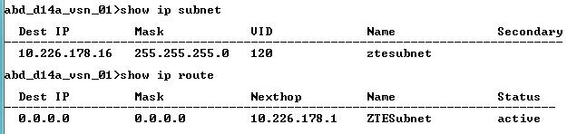

- To see the card status of DSLAM

Give command show card

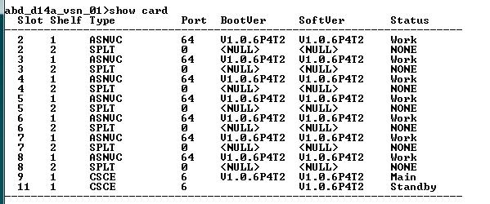

- To Reset the Non-working card ( which has ‘ Offline ’ or ‘ Unknown ’ status )

Enter into Enable Mode by Command DSLAM > Enable
Enter the Password : admin

Give Command DSLAM # reset card 3 ( where 3 is faulty card no.)
Wait for 4-5 minutes & then check the status of card again using show card command.

- To Reset the particular port

To Enter into configure mode give command configure ( in Enable /# mode )

(config) # interface adsl 2/9 ( Where 2/9 is Slot no./ Port no. )
(cf dslam(cfg-if-adsl-2/9) # shutdown
(cf dslam(cfg-if-adsl-2/9) # no shutdown
Now check the admin status of port & confirm

- To see the status of port of particular card ( to see Admin status & Link status of all ports )

Give command show interface 2/1-64 port-status
( Here 2 is card no. & 1-64 is port list, if the card is of 64 port card)

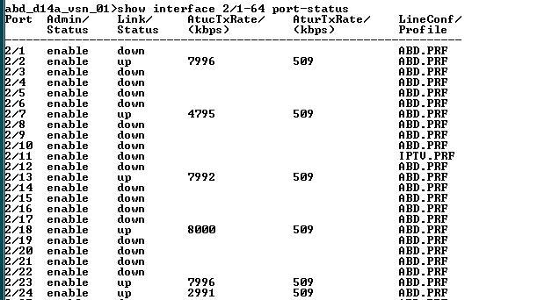

- To Check the status of Fan & Temperature in 120 port & higher ZTE DSLAM

Give command show fan

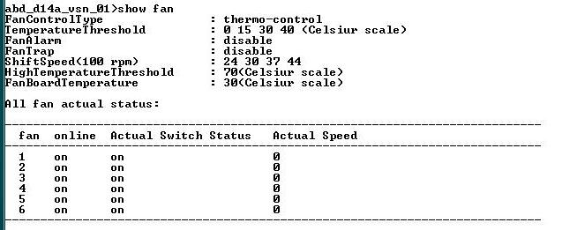
Online & Actual Switch Status of all Fans
Should be ON

- To Check status of Fan & Temperature in 64 Port ZTE DSLAM

Give command show temperature-check
Temperature should be less than 45 C
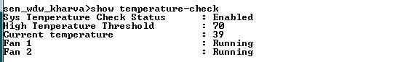
Status of Both Fans
Should be Running

If status of any fan is failed then first clean tha fan filter & check
If problem is not solved then replace the fan unit.

- To Check SNR Margin, Attenuation & out power of all ports in particular slot
( Note : Not for 64 port DSLAM )

Give command show interface 2/1-64 adsl-status

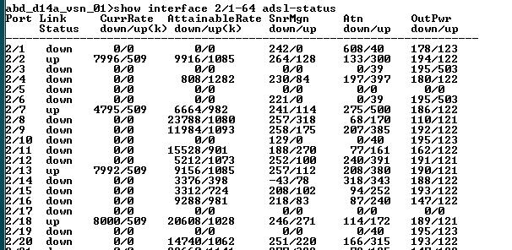
Check the
Down side
Value of SNR & Attenuation
divide it by 10

Here Divide the SNR Margin & Attenuation value by 10 e.g. Attenuation 208 becomes 20.8 dBm

- To Check SNR & Attenuation level of up ports in 64 port DSLAM

Give Command : show adsl physical 2/10 (here 2/10 = slot no./Port no. & Port is UP)

Note : Link status of the port must be UP, whose SNR & Attenuation is being checked

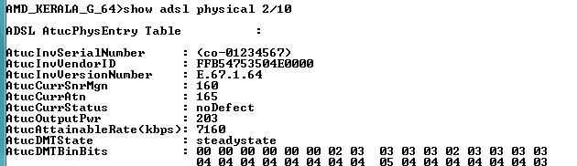
Check the
Down/ATU-R side value of SNR & Attenuation
divide it by 10

- To find slot no./ Port no. in DSLAM from VLAN id

Give command show vlan 229 ( here 229 is inner VLAN id )

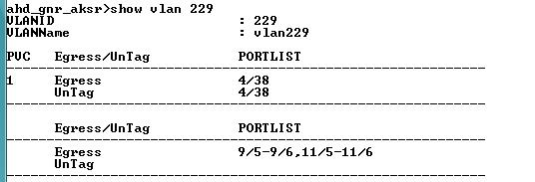
Port no. of VLAN 229

- To Check Uplink port Status & VLAN passed from uplink port of DSLAM

Give command show interface 9/1-6 port-status

show interface 9/1-6 vlan-config
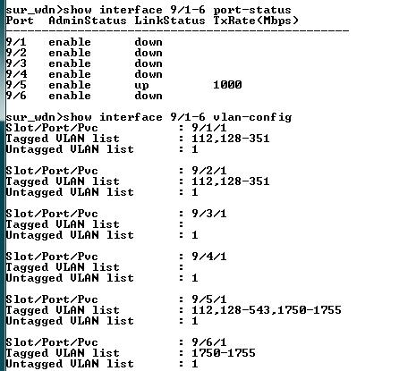
Port 9/5 is UP so it is active uplink of DSLAM
Management & inner VLAN tagged in DSLAM uplink port 9/5

- To Check Uplink port Status & VLAN passed from uplink port of 64 Port DSLAM

Give command show interface 5/1-2 port-status

show interface 5/1-6 vlan-config

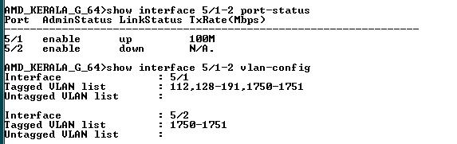
Port 5/1 is UP so it is active uplink of DSLAM
Management & inner VLAN tagged in DSLAM uplink port 5/1

- To Check MAC Address of all up ports in particular slot
Give command show mac-address-table slot 4 ( 4 is slot no. - Not for 64 Port DSLAM)
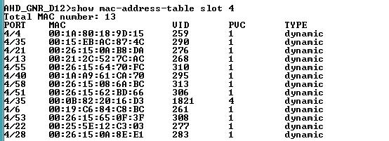
- To Check MAC address list of all up ports in 64 Port ZTE DSLAM
Give command show mac-address-table

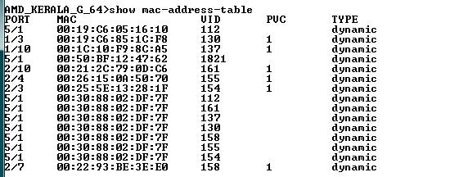

(B) Commands for UTstarcom DSLAM

- To Check The All Card Status

Give Command – ‘show slot’

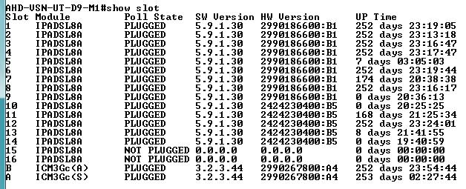

IPADSL8A is Line Cards & ICM3Gc is Controller card.
(A) is Active and (S) is Standby

- To Check the Module Status & Temperature of Particular Slot
Enter into particular Slot DSLAM # slot 1 ( here 1 is slot no. )
& Give command : show module &
show temperature

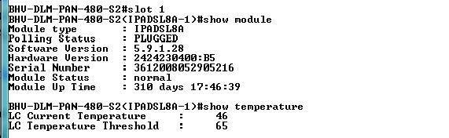
Card/Module Status should be Normal, for faulty card the status will be Unknown
Slot temperature should be less than 45 ̊ C

- To Reset the Non working Card ( with Unknown Module status )

Give this command : # reset 2 hard ( here 2 is faulty slot no. )

Always use Hard Reset to RESET the Cards. AFTER Resetting the Card, To check the card Status give command Show Slot as above
If there is problem in any Card then S/W Version and H/W Version of card will not display. Sometimes Card is already plugged but card status shows Unplugged. So, there is a fault in that Card. In that case inform to Service Provider & follow their instructions to confirm fault.

- To Check Status of all ports in particular card
Go into Proper SLOT and into Port Mode

Each Card Contains the 48 DSL Port (1 to 48): According to this, calculate the right port.

Give command: # slot 4 ( here 4 is slot no. )

# port ( to enter in port mode )

# show line dsl 1-48 ( 1-48 is port range for 48 port card )
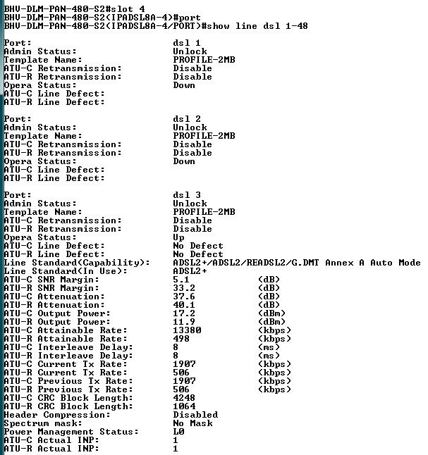
CPE is not ON so Operation Status of port shows Down
You can check SNR & Attenuation level of particular port if it is UP

- To Reset the particular Faulty Port ( Use Disable or Enable the PORT)
Enter into concern slot & then enter into port mode.
Give the Command:

AHD-DLM-NVP-UT12-M1(IPADSL8A-4/PORT)# disable dsl 19
AHD-DLM-NVP-UT12-M1(IPADSL8A-4/PORT)# enable dsl 19

When the port is disabled then the Port Admin Status becomes ‘LOCK’

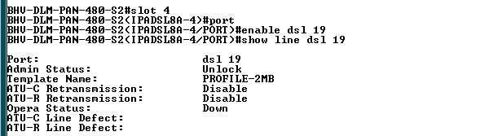

To Reset Series of Port

Enter into concern slot & then in port mode & suppose port no. 1 to 8 are faulty

Give Command : # disable dsl 1-8 ( here 1-8 shows series of dsl port 1 to 8 )

# enable dsl 1-8

# show line dsl 1-8 ( to check the admin status of ports )

- To Check the Current MAC address on Up ports of particular slot

Give command : # slot icm ( or enter slot1/2/3 to check mac in particular slot)

# bridge

# show fdb

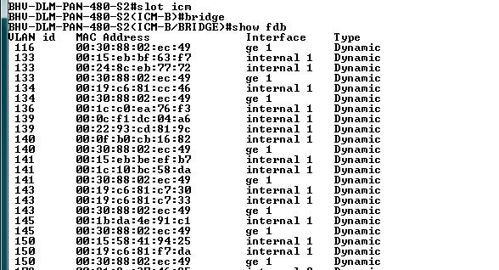

- To Check the IP route
Give command : # ip show route

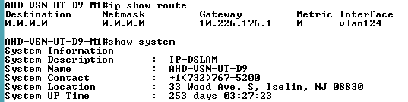

- To Check the DSLAM System Up time
Give Command : # show system
- To Check the VLAN Configuration of ports in Particular Slot
Give command : # slot 3 ( Enter into particular slot )
# vlan
# show ( or enter show 226 to find particular port from vlan )

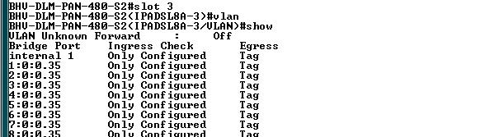

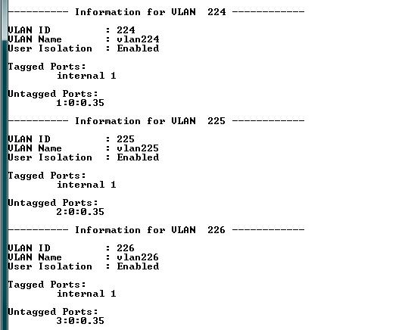

( C ) Commands for NOKIA SIEMENS DSLAM

To login into the NSN DSLAM, get connected to Operation Domain VPN & Telnet the DSLAM

Enter Login id- root
Password- vertex25
Give command : enable ( to enter in enable or # mode )
configure terminal ( to enter in configuration mode )

- To see the status of card
Give Command : show slot-overview
It shows the status of all equipped card in module.
Each card contains 72 ports. Here Control cards are equipped in slot no.5 and 6.

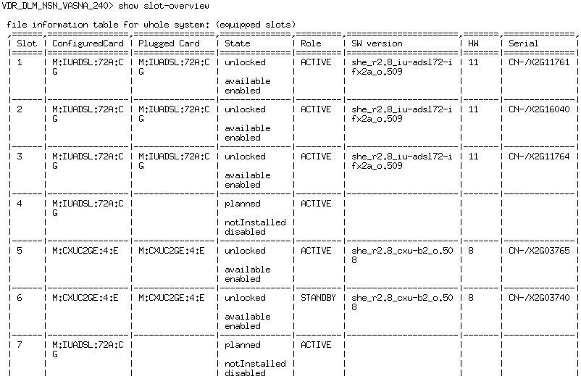

- To Check the Status of Fan

Give Command : show status fan
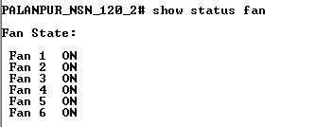

- To Check the configuration of each card separately
Give Command : show table shelf

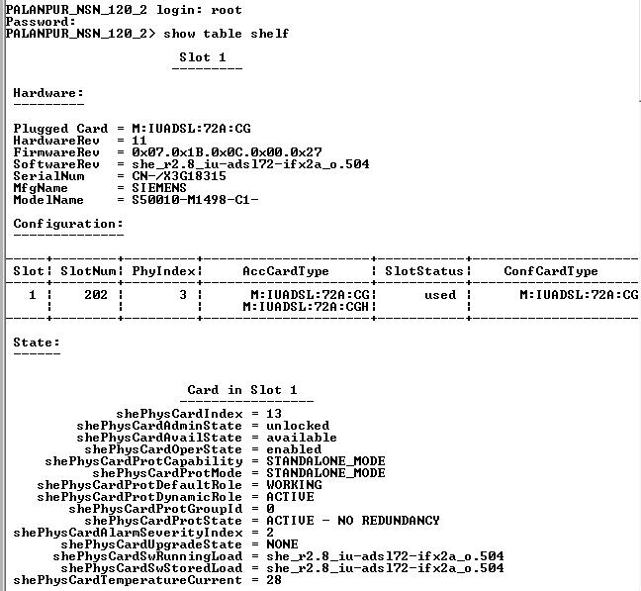

- To Check the Card temperature of all Equipped Cards
Give Command : show status temperature

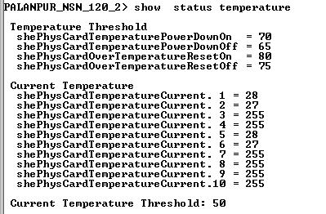

- To Check the Port Admin & Operation Status & xTUC & xTUR Line Rates

Give Command : show lre s1 xdsl phys-table linerates
(Here s1 indicates the slot no. 1, enter s3 for slot 3 )

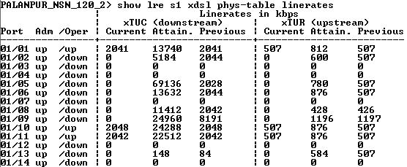

- To find the Slot & Port no. from particular inner VLAN & to Check the MAC

Give Command : show mac vlan 137 ( here 137 is inner VLAN no. )

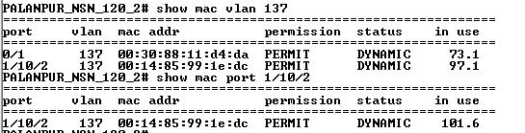

- To Check the Attenuation & SNR Margin for particular UP port
Give Command : show lre 1/10 xdsl band-table ( 1/10 is slot no. / port no. )

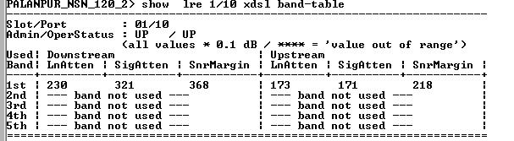

- To Reset the particular faulty card

Enter into Enable Mode by using command > enable
Enter into Configuration Mode by using command # configure terminal
in configuration mode give command :
DSLAM(config)# reset card 2 ( here 2 indicates the slot no. )
OR DSLAM(config # reset all ( to reset all equipped cards )

- To Reset the particular Port
Enter into Enable Mode by using command > enable
Enter into Configuration Mode by using command # configure terminal
In configuration mode give command
DSLAM(config)# bridge
DSLAM(config # port lre 2/5 disable ( here 2/5 is slot/port no. )
DSLAM(config # port lre 2/5 enable
DSLAM(config # show lre s2 xdsl phys-table linerates (check the port’s admin status )

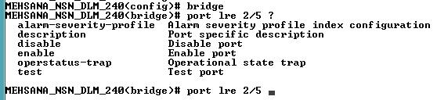

To Reset the series of Port
DSLAM(config # port lre 2/1-15 disable ( here 2/1-15 is slot / series of port no.)
DSLAM(config # port lre 2/1-15 enable

PART – 3 ZTE OCLAN Functional description of LEDs in
various card

ZTE - ZXR10 T64G OCLAN

ABRIDGED GENERAL VIEW OF ZXR10 T64G OCLAN COMPONENTS POSITION

In ZXR10 T160G, 8 line interface cards can be plugged in; while in ZXR10 T64G, when master/slave control is not needed, 5 line interface cards can be plugged in, and when master/slave control is needed, 4 line interface cards can be plugged in.

FUNCTIONAL DESCRIPTION OF FRONT PANEL LEDS IN
44+4 FAST ETHERNET INTERFACE BOARD

The functions of forty-eight ports corresponding to the 48 LEDs in the front
panel of 44+4 fast Ethernet interface board are described below.

FUNCTIONAL DESCRIPTION OF FRONT PANEL LEDS IN THE CONTROL SWITCHING BOARD

THE FRONT PANEL OF ZXR10 T64G MCS

FUNCTIONAL DESCRIPTION OF BUTTONS IN THE CONTROL SWITCHING BOARD

FRONT PANEL VIEW OF 24 PORT GIGABIT ETHERNET OPTICAL INTERFACE BOARD

Twenty-four-port gigabit Ethernet optical interface board provides 24 gigabit
Ethernet optical interfaces, 4 of which support Optoelectronic self-adaptive.

FUNCTIONAL DESCRIPTION OF FRONT PANEL LEDS IN 24-PORT GIGABIT ETHERNET OPTICAL INTERFACE BOARD

FRONT PANEL VIEW OF 12 PORT GIGABIT ETHERNET OPTICAL INTERFACE

Twelve-port gigabit Ethernet optical interface board provides 12 gigabit Ethernet optical interfaces, 4 of which support Optoelectronic self-adaptive.

FUNCTIONAL DESCRIPTION OF FRONT PANEL LEDS IN 12 PORT GIGABIT ETHERNET OPTICAL INTERFACE BOARD

Part - 4 NMS / EMS for Multiply BB Equipments

NMS / EMS (Network / Equipment Management System) for RPR is a web based application which has to be accessed every time through operations VPN. The node in charge has to get the username and password for logging into the VPN. Whereas, EMS for DSLAM is a client based application. This client is common for both OCLAN and DSLAM which can be downloaded through internet (Not from operations VPN). This downloading is required only once for the first time. The detailed procedure is as below.

UTstarcom NMS

RPR NMS
Netman-6000 OMC-O
DSLAM NMS
Netman-4000 OMC-A

Open Internet Explorer and type the IP
http://172.30.4.15:9090

Download & Run
jre-1_5_0_09-windows-i586-p.exe

Note : This downloading is common for RPR & DSLAM NMS and required to be installed for the first time only

Then click on Click here for Login
( you will see java loading, and prompted to login )

Username : BBMPGUJ

Password : ********

Open Internet Explorer and type the IP

http://172.30.4.21:9090 (Chennai)

http://172.30.60.11:9090 (Bangalore)

Download & Run
jre-1_5_0_09-windows-i586-p.exe

Then click on Click here for Login
( you will see java loading, and prompted to login )

Username : BBMPGUJ

Password : ********

Note : For Windows Vista users

download & install the file jre-1_5_0_12-windows-i586-p.exe from internet
from the URL as given below.

http://www.livingresources.org/livresforms/Downloads/jre-1_5_0_12- windows-i586-p.exe

ZTE NMS

DSLAM NMS

Download Client Software from
ftp 172.30.20.229

Login interface appears after the client gets started

User name : xxxxx
Password : xxxxx

For Username and Password already circulated to Node In charges.

Select Server address: 172.30.20.232

For any technical help may be contact on 09964658029
or
E-mail : zterural@gmail.com

Netman 6000 OMC–O

UTstarcom RPR Network Management System (NMS)

Netman-6000 OMC-O NMS for RPR is a web based application which has to be accessed every time through Operation Domain VPN. The node incharge has to get the username and password for logging into the VPN.

Get connected to Operation Domain VPN.

Open Internet Explorer & Type the IP http://172.30.4.15:9090

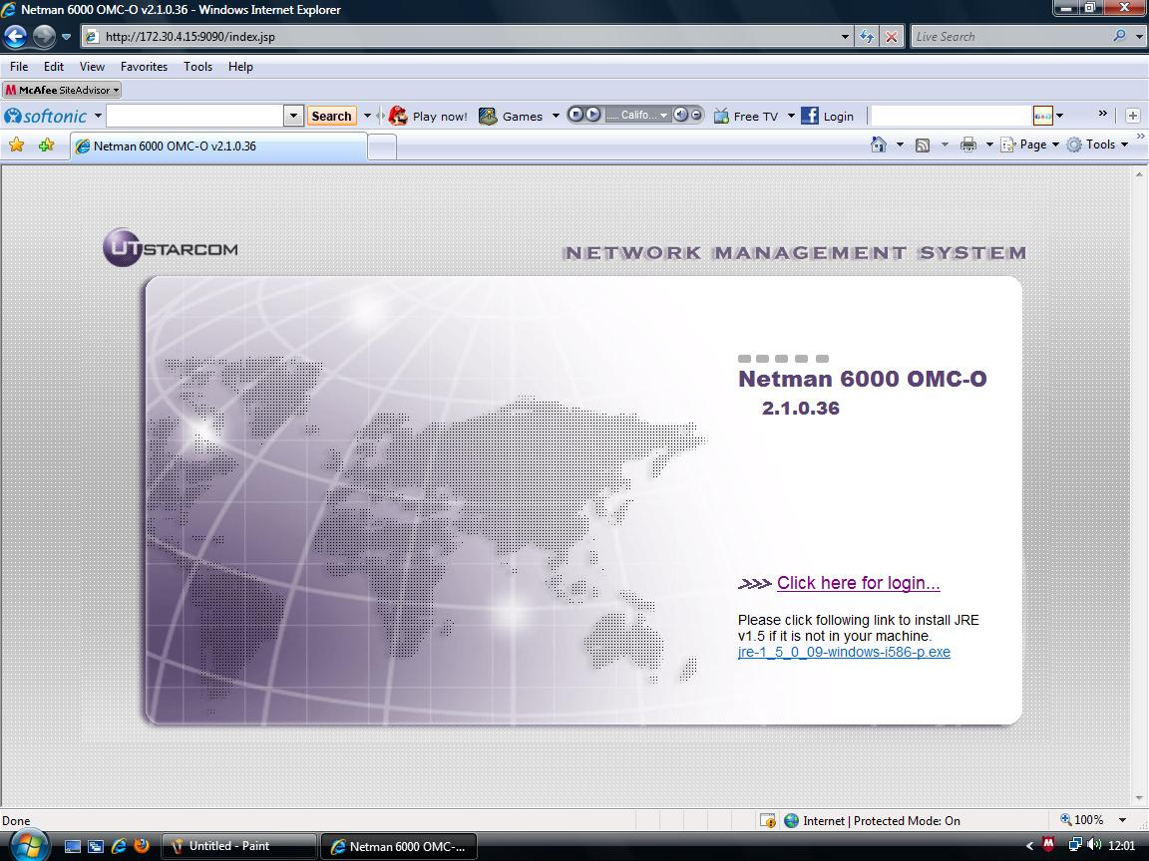

Note :

(1) If you are using Netman-6000 first time with your PC with Windows XP &
if jre-1_5_0_09-windows-i586-p.exe is not installed in your computer then click on link
shown in that page & let the software to be download & Run.

(2) If you are using Windows Vista then from internet download the
jre-1_5_0_12-windows-i586-p.exe file from the URL as given below.

http://www.livingresources.org/livresforms/Downloads/jre-1_5_0_12- windows-i586-p.exe

Then click on “Click here for Login” ( You will see Java loading and prompted to Login )

In login Window Enter Username & Password as provided to concern Node/NIB incharge

Important :

Please Enter the correct Username & Password carefully. If you see the Message for Incorrect Username or Password once , don’t enter wrong Username & password 3/ 4 times otherwise the Account will get locked.

In case of Account get locked please immediately contact Bangalore NOC to unlock the account.
Also don’t change the Password because all Node In charges in Gujarat are using the same user id & password. This will cause the Account locked as mentioned above due to wrong password submission by other Node in charges.

In main window you can see View Tree of all Rings ( at left side ) & Physical View window.

Click on Expand sign of Gujarat to see Tree view of all Resilient Packet Rings (RPR) SSA wise.

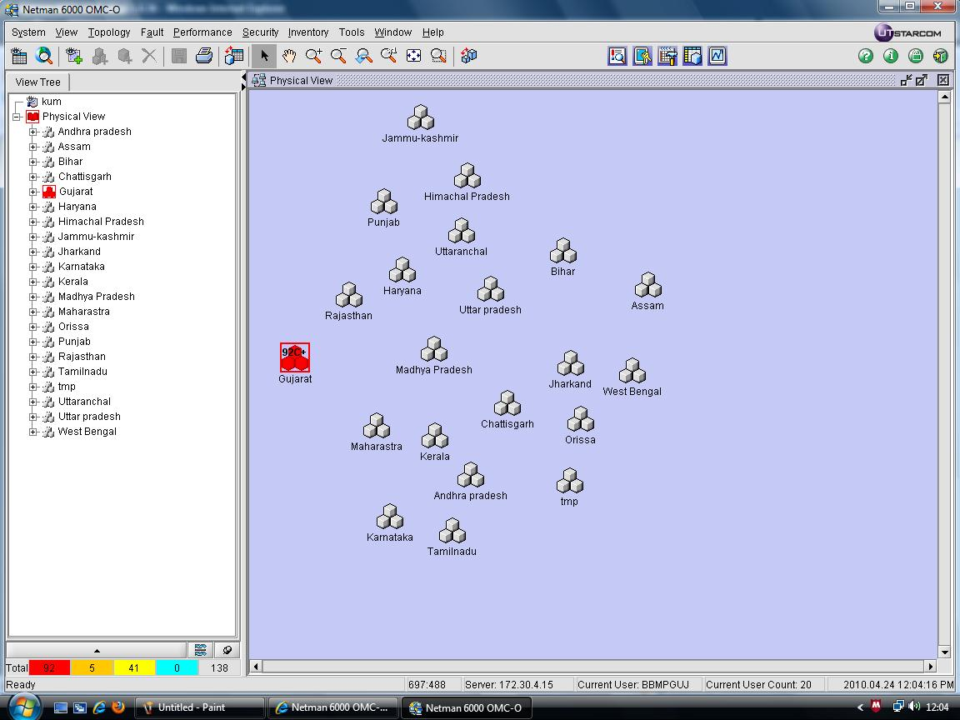

Click on any RPR label to see that ring’s configuration & all NEs connected to that Ring.

GREEN color of Link between any two NE shows Normal/healthy Link.
In case of Link failure between two RPR NEs , the link color becomes RED.

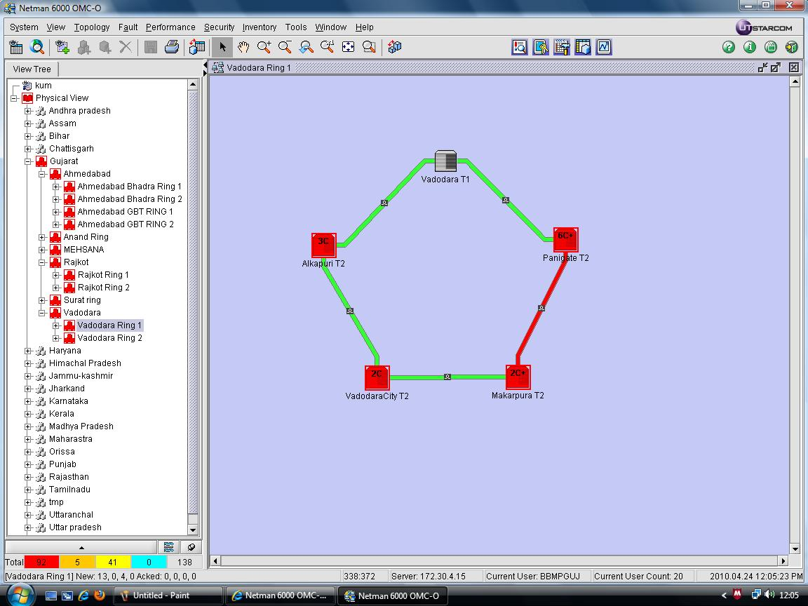
Green
Normal
RPR Link
Red
Failed
RPR Link

For RPR Switch’s Optical Power Measurement

In Menu Bar at top Click on - Performance → Real-time Performance Monitor

Click on New Real Time Monitor icon ( 1st icon at the top )

In New Real Time Monitor Window Enter

Monitor Name : Insert any name you want related to NE label
NE Type : Netring 10000R ( Default )
Measurement Type Set : Netring 10000-R_Measureset_1.2.0.8 ( Default )
NE Version : 1.2.2.4
Measurement Type : OSPI
Polling period (Sec) : 3 ( Default )

Tick on Ospilopcur in Measurement Item List Box

Now find the RPR NE label from the list given in Measurement Object List.
Click on Expand sign to see slots of that NE & tick on the slots whose optical power you want to measure.

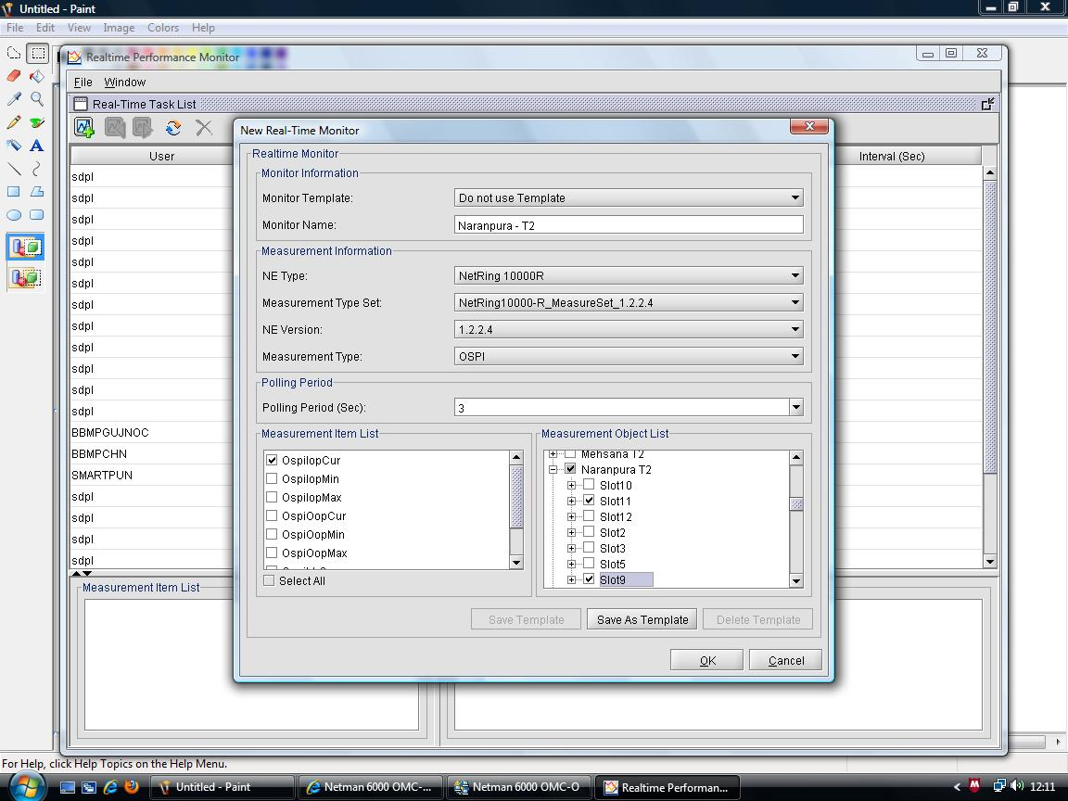

( For example if that NE is connected in Ring via slot-9 & slot-11 & you want to measure these
slots then tick on slot-9 & slot-11 )

Then click on OK & wait for a minute.

Now you can see the Real Time Monitor Window of that NE which shows slot wise Optical Power in dBm for that NE.

Optical Power of slot-11 in Graphical view

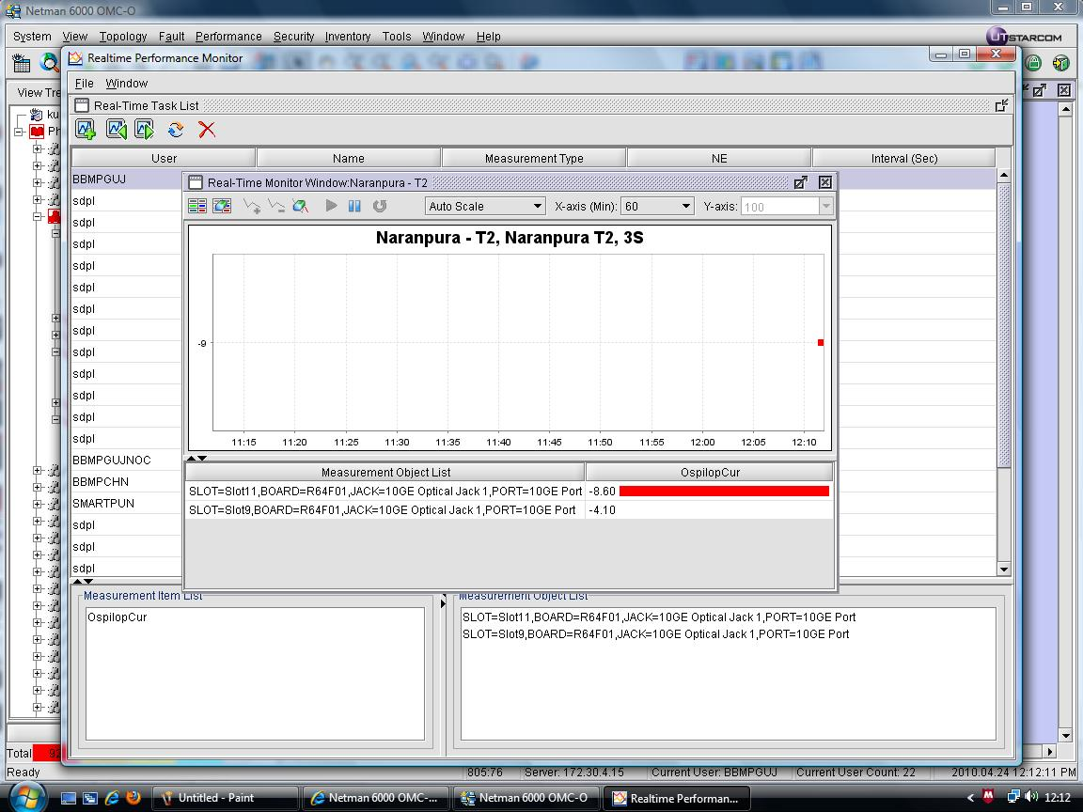

Optical Power (dBm) of slot-9 & slot-11

Permissible Receive Optical Power Range on the Links connected on T1 & T2 Rings
are as listed below :
For 1 GB Links Card Type : RGEF02 ( GE RPR Line card ) | -10 dBm to - 20 dBm
For 10 GB Links Card Type : R64F01 ( 10G RPR Line card ) | - 9 dBm to - 14 dBm

To Check Temperature of particular slot of RPR switch.

Open NE shelf view by Double click on T1/T2 NE icon

If any slot of RPR switch has high temperature in shelf view that slot’s color will change to RED.
To see the Threshold temperature & current temperature of that slot right click on slot
Then click on - Equipment > Equipment property
- Temperature Threshold Configuration

Here you can see that slot’s set Threshold Temperature.

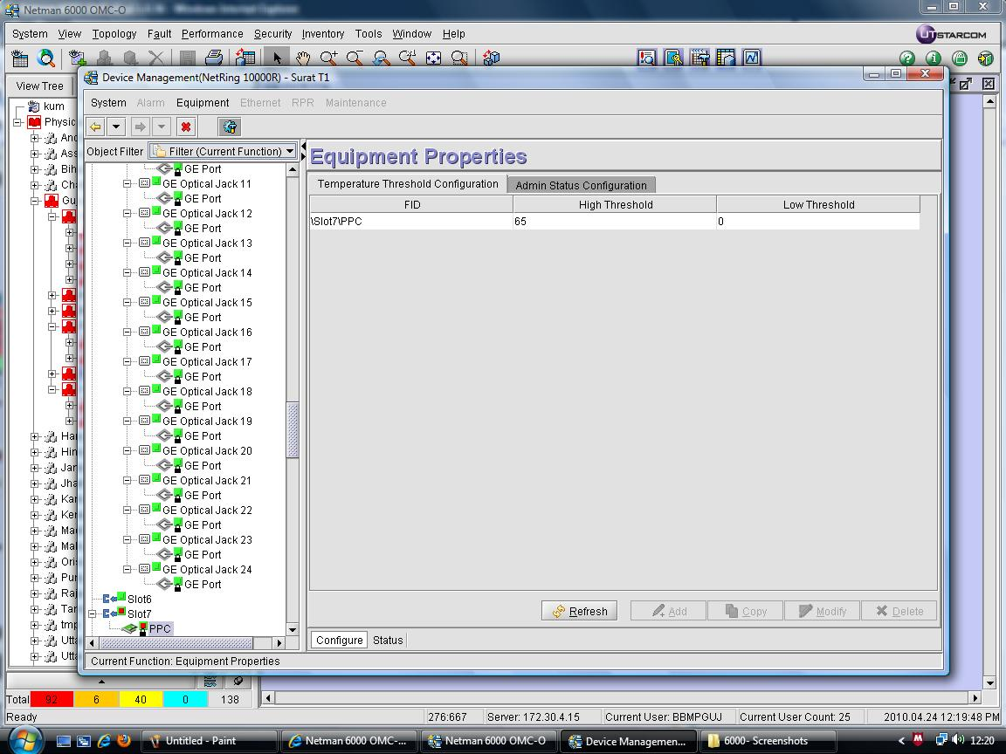

Now click on Status tab

Click on Physical Object Temperature to see slot’s Current temperature.

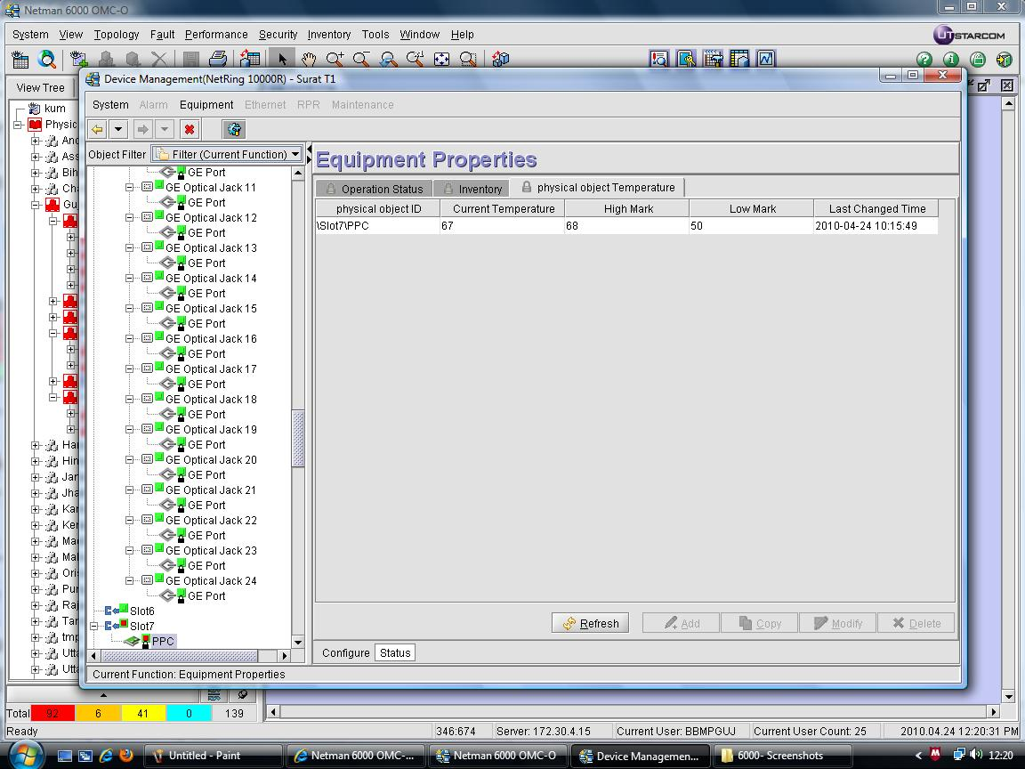

Netman 4000 OMC–A

UTstarcom DSLAM Network Management System (NMS)

To Access Netman -4000 get connected to Operation Domain VPN. Open Internet Explorer & Type the URL

http://172.30.4.21:9090/index.jsp

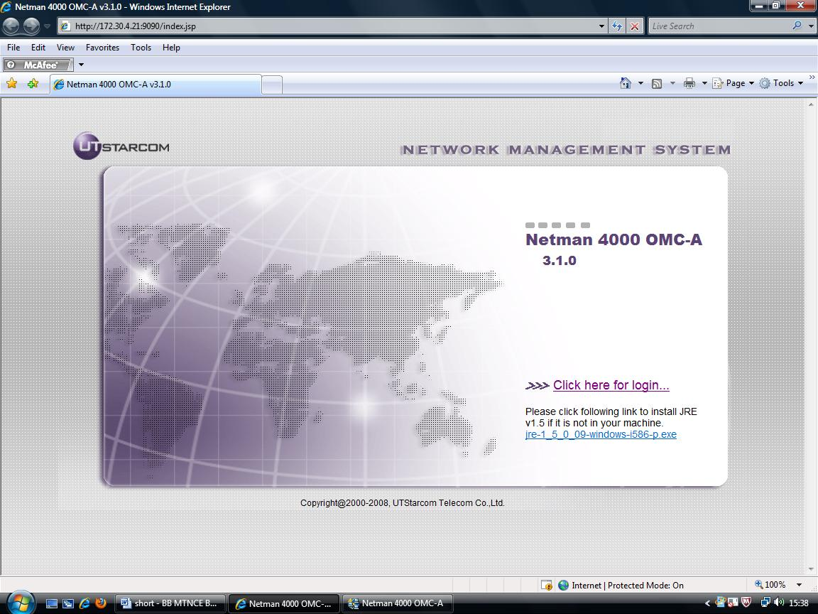

Now Download & install
Windows XP users : jre-1_5_0_09-windows-i586-p.exe (from netman-4000 login page )

Windows Vista & higher version users please download & install the
jre-1_5_0_12-windows-i586-p.exe file from the URL as given below.

http://www.livingresources.org/livresforms/Downloads/jre-1_5_0_12- windows-i586-p.exe

Then click on “Click here for Login” ( You will see Java loading and prompted to Login )

In login Window, Enter Username & Password provided to NIB/Node Incharge

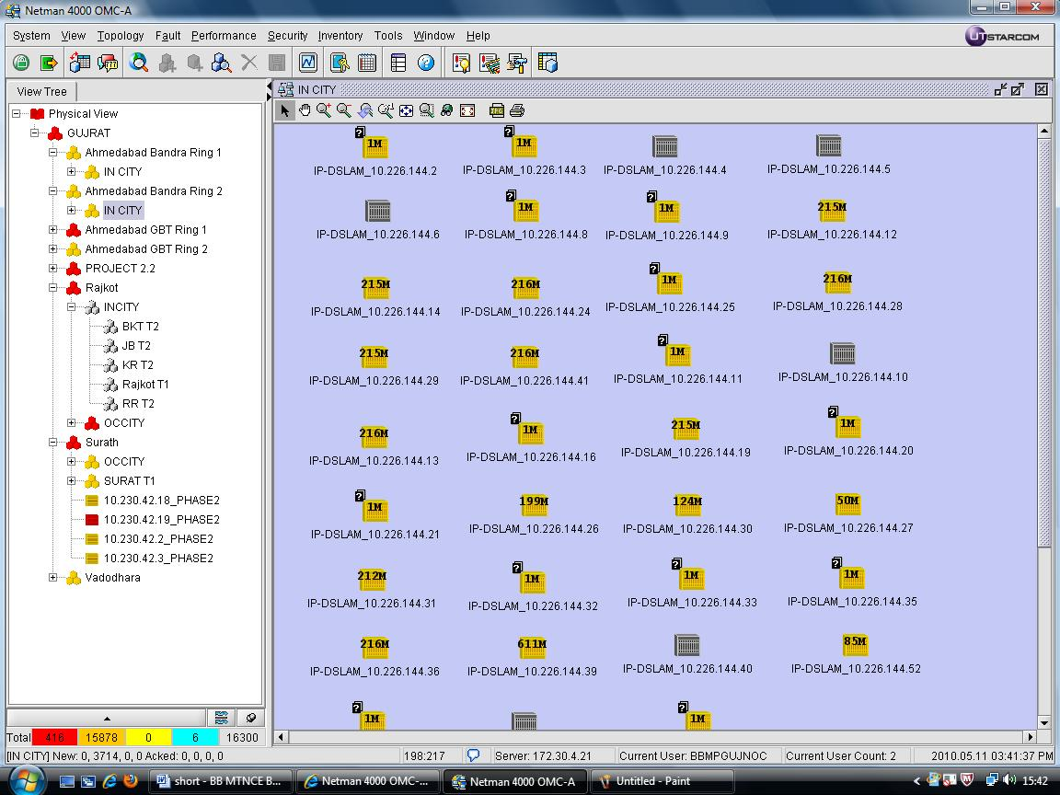

Netnumen

ZTE - DSLAM Network Management System ( NMS )

NetNumen N31 Installation and Configuration Steps :

How to download EMS client,

From Operation Domain VPN , you had better use ftp client to download

1. Open run window & enter ftp 172.30.20.229
2. When asked for Username/password give Username : test & Password : test
3. ftp>bin
4. ftp>get netnumen.rar (please wait patiently, it will take about 40 minutes)
5. ftp> lcd ( Plz note the netnumen.rar file saving path displayed )
6. ftp>bye ( now close the DOS windows)
7. using Windows environment, in above directory(the path that 'lcd' shows),unzip
the netnumen.rar file
8. Now go to netnumen folder and then enter bin folder
9. double click on startNms Client.bat batch file.
Now enter Server Address 172.30.20.232 to login , enter Username &
Password given to you at this time ,EMS client will be upgraded automatically
( Now press any key to continue)
- use 172.30.20.232 to login again.
- now open netnumen folder from your given destination drive >
open folder bin then select configcenter file then open it then figure no.8 will
be displayed wait for it. Follow the steps below to configure the Ems.

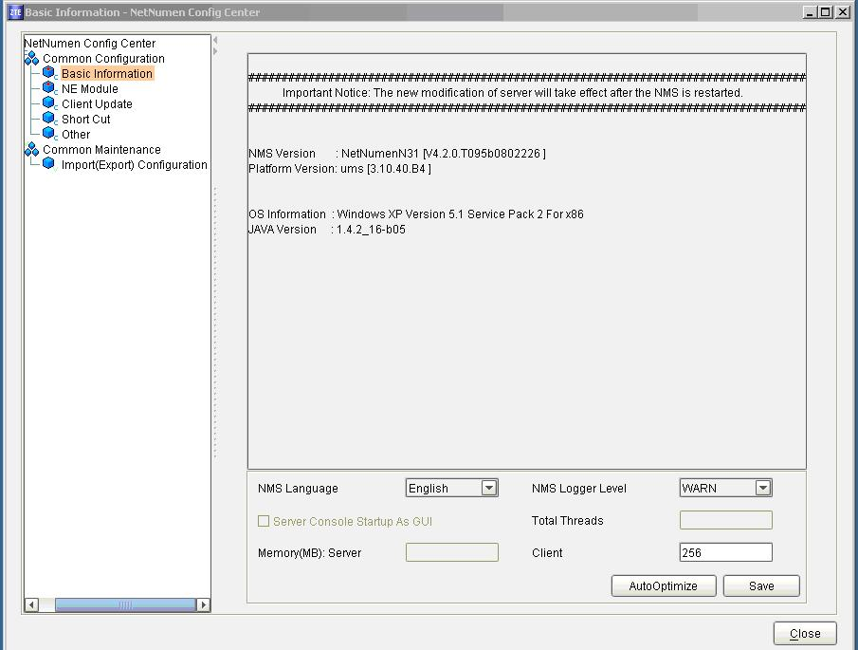
13. Select the language , Software edition and the related information of
operating system and database are displayed in the right part of interface.
14.. Enter into NE Module view, select Products DSL product only to manage , and
click Save and click on close.
15. select NMS Logger Level- WARN and default client - 256
Now click on save button.
16. After some time saving successfully message will be displayed. > then close this
window.
17. Now click on the startNmsClient windows batch file to open the the Ems ZTE

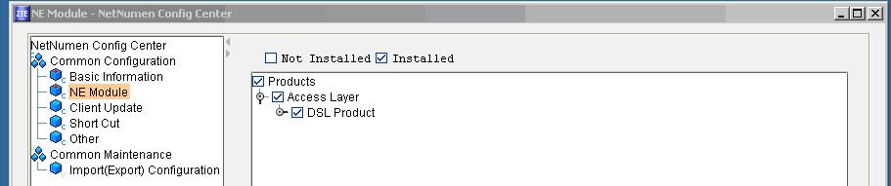

END OF STEPS

Result : NetNumenN31-V4.2.0 has been installed.

Starting NetNumen N31 Client

To start NetNumen N31 Client, perform the following steps.

1. Get connected to your Operator VPN the same VPN which was used for logging
into p2.2 network.
2. Start client. Click Start → All Programs → NetNumen N31 → NetNumen N31Client
3. Another method to start Client. Run %NETNUMEN N31 Install Dir%\umsclnt\
bin\run.bat file, as shown in Figure 10.

4. Login interface appears after the client gets started, as shown in Figure 3. Set
Enter User name and Password provided to NIB/Node Incharge.

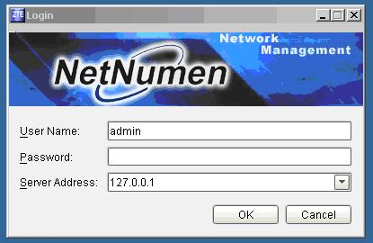

Note : Default server address is 127.0.0.1,

change the Server Address to 172.30.20.232 for DSLAM EMS

NetNumen N31 Unified Management System interface appears.

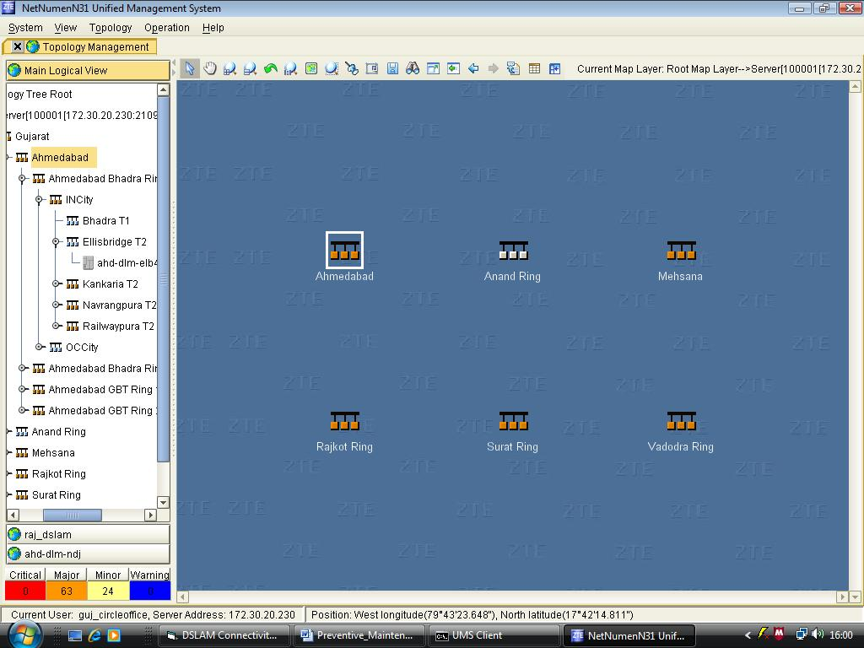

This shows NE group RPR Ring wise.

Part - 5 DSL Tester

ADSL2+ tester is a much compact and very easy-to-use handheld test instrument. It can support various ADSL line standards, especially for installation, maintenance and measurement of DSL line parameters.

Steps to configure Aurora Presto for testing

(A) Basic Requirements before starting the test:- (One time or on first use only).

1. DSL line should be provisioned on the link to be tested and username and password should be handy with to you.
2. Connect DSL link to Line port of Aurora Presto using cable provided along the instrument.
Go to initial screen press F4 go to Modem in Main Setup
3. Select in Modem Setup
Type: CN ATU-R+,Mode: ADSL2+,Training: Auto,
Tracer Settings
Trace: All,Trace DSL: On,Trace DSL Alms: On,Trace PPP: On
4. Go back and Select ATM

VPI: 0

VCI: 35
VC Mode: VC Enabled

(B) Following configurations are optional/required for PPPoE mode test given in para (D)
only.

5. Go back and Select IP
Mode: PPP,Port: VC 1,IP Address Setup,Origin: IPCP
6. Go back and Select PPP
Type: PPPOE,Mode: Client
User: user name of DSL line
(for small alphabets or special characters use the Page Dn key)
Password: password of DSL line
(for small alphabets or special characters use the Page Dn key)
Attempts: 25, Init Mode: Auto, Pool Size: 1
Tracer Settings
Trace: All, Trace DSL: On,Trace DSL Alms: On,Trace PPP: On
To check the status on Presto is synchronized with DSL line.
Check LED’s, Sync LED will be stable green and DSL link will be blinking green/red.

(C ) Testing of Broadband connection through DSL tester via RJ-11 Port.

( For cheking attainable bit rate at new customer location in case of doubt without need of a modem)

(i) First connect the telephone line of customer on any spare DSLAM port in MDF (same as
for new broadband connection).
(ii) Connect RJ-11 cable of telephone line at customer premises into the tester on port (RJ- 11).
(iii) Power on the tester.
(iv) Select Manual test on the menu and press enter.
(v) Select operation.
(vi)Select DSL layer and enter.
(vii) Select DSL test and Select DSL statistics and press enter.

The following parameters will be displayed on the screen,
- Noise margin ( it should be more than 10db)
- Attenuation ( it should be below 40db)
- Attainable bit rate (it should be more than 256kbps)

(D) Testing of Broadband connection via RJ-45 Port on existing CPE at customer premises.

Ethernet cable of ADSL CPE connected to PC side may be jacked out and connected to DSL tester on Ethernet port for checking of download/ upload speed of broadband, ping test, website ping and authentication test and DSL line parameters like SNR, attenuation & attainable bit rate. The following procedure may followed.

- Connect the RJ45 cable from CPE to DSL tester.
- Power on
- Manual test
- Select DSL layer
- SNR, attainable bit rate & attenuation can be seen.
- Select IP layer
(vii)Check the ping test & trace route.
(viii)Select http test
(ix)Check the web site authentication

Part - 6 (A) Broadband related important tips
(B) Broadband error codes & remedy
(C) Important vendor contact detail

(A) Broadband related important tips

FACTORS HAMPERING THE BROWSING SPEED

1. Virus Infected PC
Check for the virus infection. Scan thoroughly to remove complete traces of virus. Make sure that the system is virus free and not performing in a sluggish way without connecting to the internet

2. Low SNR
Line attention is in relation to the "loop loss" on your line. The further you are away from the exchange the higher your attenuation figure will be as the signal loss increases. The lower your attenuation figure the more chance you have of getting the faster speeds. In general higher Signal To Noise Ratio will result in less error.

SNR MARGIN | REMARK
6db or low | Bad and will experience no line synchronization or intermittent synchronization problems.
7db –10 db | Fair but does not leave much room for variances in conditions.
11db –20 db | Good with little or no synchronization problems
20db –28db | Excellent
29db or above | Outstanding

3. Wrong ADSL Line profile attached in DSLAM port for high speed plan
- Check for the correctness of the Speed profile attached to the connected port.
- Normally for ADSL ports are configured for 2Mbps profile.
- For high speed plans configure the port manually

4. Packet loss at the connected NE
- Packet loss at the connected network element impart slow speed to the customers connected from the concerned Network element.
- Ping with certain packet size for checking packet loss (Command: ping –l Size IP Address)
- Example for 10 Bytes packet size: ping –l 10 218.248.240.79
- If there are any loss please check the media/connectivity.
- Make sure that the no packet loss are incurred

5. Low power in the RPR ring
- Low power in the RPR ring may inversely affect the speed. Ensure the power levels are well with in limit. Threshold set for RPR rings
- In case of low power please check transmission media termination/joints.
- In case of high power level please use pads to reduce the power level pads.

Ring | Threshold set
1G Ring | -22db
10G Ring | -14.1 db

6. Cascading of OCLANs
Many OCLANs are cascaded with out master OCLAN Uplink media up gradation to GE. Many places the mater OCLAN uplink is still FE and cascading is done with out taking in consideration that the traffic from the cascaded OCLANs also will flow through the Master OCLAN UPLINK.

Calculate the expected traffic which will flow through the master OCLAN UPLINK after cascading and go for the media up gradation . Cascading of too many OCLANs with out proper planning will definitely hamper the service

7. Wrong AAA policy attached in LDAP
- Check for the correctness of the AAA policy assigned in LDAP for the customer
- AAA policy in turn will define the speed
- If the AAA policy is not assigned as per the plan speed may vary
- Consult with NOC for the correctness of the AAA policy as per the Plan.

8. High DNS resolution time
- Resolution time may be high in case of the connected DNS failure/ DNS overloading
Will affect all the customers connected to the concerned DNS
- perform nslookup from the field as a first level for trouble shooting . (Please see next slide for procedure of nslookup)
- Inform to NOC in case of any issue or change the DNS in LAN setting to some other working DNS.

Note: DNS changing may in turn affect the password/ Redirection

Procedure for nslookup:
- Click Start, Run , type “ cmd” in the box and press enter to open command prompt alternatively in the windows operating system click programs, accessories, and command prompt to open command prompt window.
- In the command line type “ nslookup“ and press enter to get the DNS
- IP address of the network is shown (Please see the screenshot on next slide).
- type “ server 218.248.255.141 ” (OR type the IP address you got in the command line) and press enter
- type “ www.yahoo.com” and enter (OR type your problematic url)
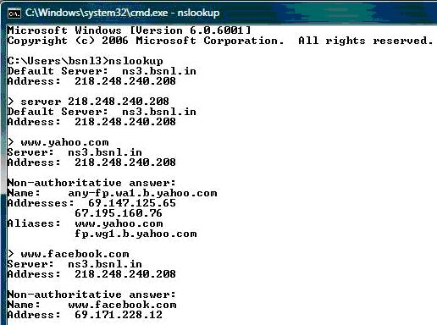
Result of the above commands has been shown in the screen shot on next slide. If you see like screen shot result ,It means that site is resolved by DNS. If not, please mail to bbnoc_mp@bsnl. In by attaching the screenshot of the result.

- High latency at MPLS
- Check the latency from one hope to another using trace route command for the problematic sites.
- Latency of 350-400 ms are permissible between two hopes
- Inform MPLS NOC/ MP NOC in case of any abnormality/High latency

Procedure:
a) Open the command prompt.
b) type “ tracertwww.yahoo.com “ and press enter (OR type the problematic site instead of www.yahoo.com
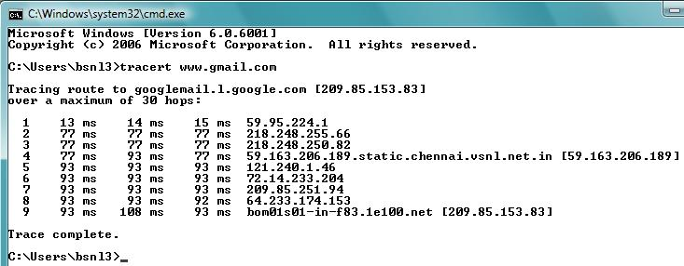
In the result you will see the latency taken to reach the destination IP hop by hop. In the See screen shot on next slide there are latency observed at any hop is less than the maximum allowed range i.e., 350ms to 400 ms.

If the latency is more than the allowed range at any hop please escalate the issue with the screen shots to bbnoc_mp@bsnl.in with a copy to mplsnms@gmail.com.

- Reverse trace route (TRACE ROUTE OF IP ADDRESS ALLOTED TO SUBSCRIBER)

Procedure:
a) Go to the site http://network-tools.com/
b) In the box the dynamic public IP address allotted to the customer is displayed.
c) Select the “ Trace” radio button and click Go.
d) The result showing the latency taken to reach the source IP hop by hop. Please see screen shot on next slide there are the latency observed at any hop is less than maximum allowed range i.e. (350 to 400 ms).

If the latency is more than the allowed range 350 to 400 ms at any hop please escalate the issue with the screen shots to bbnoc_mp@bsnl.in with a copy to mplsnms@gmail.com.

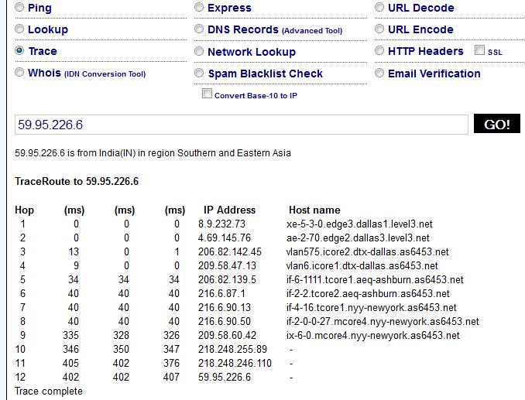

For Reliable and Speedy Internet Connection :
1. SNR value must be greater than 13. See DSL line parameters in Modem. If value is below
than 13 then change line, vertical, DP or pair.
2. Attenuation level must be less than 40. See DSL line parameters in Modem. If value is
greater than 40 then change line, vertical, DP or pair.
3. ADSL Splitter must be used on a Telephone line at subscriber premises.
4. Also Before splitter there must be ----
No Parallel Phones Connection,
No Intercom,
No EPBAX,
No Joints/Cuts in Line,
No Conduit/Internal Wiring.
All the devices must be used after ADSL splitter.
5. Telephone Line Path should be away from Electrical Lines/Equipments/Devices.
6. All Terminals or Connecting Points must be Clean and Rust free.
7. If the distance (underground cable) of the subscriber's modem is more than 2 Kms from the
Telephone Exchange (DSLAM) then Use only G.dmt Modulation in the modem DSL
settings. Disable all other modulations.
8. Try to Use power from UPS supply for Modem's adapter to avoid fluctuations.

Power Range of Optical Transceivers for

Broadband Multiplay Equipments

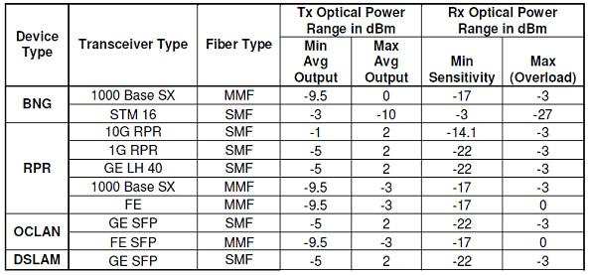

Trouble shooting of some common broadband problems

TIPS FOR GOOD BROADBAND SPEED TO THE CUSTOMERS

1. Check the drop wire :
The drop wire from the DP box to the customer house should be as straight as possible, should be a single length without joints. The drop wire should not be coiled anywhere and also should be away from electrical lines. If these are not taken care then telephone may work fine but broadband connection may disconnect, frequently.
2. Splitters and Parallel telephones :
The splitter separates the high frequency ADSL signals from low frequency telephone signals. If the splitter is not installed correctly the broadband will go down every time there is an incoming call.
Any parallel phone connection in the customer premises should be after the splitter. There should not be electrical wires running parallel to the wires going into the modem.
3. The SNR may be checked by going into the modem settings and further into ADSL line parameter where SNR Margin and attenuation can be checked. The SNR should be minimum 13 or above and attenuation should be as low as possible. If attenuation goes above 40 or SNR goes below 13 then the subscriber outdoor line need to be attended / changed.
4. The Nuisance & Danger of Virus:
One might some time feel that the broadband was quite good some time back but it is slow nowadays. One of the major reason for this is the infection of Virus into the PC. Adwares, spywares too may affect speed. Hence, it is very important to have a good anti-virus software and spyware, adware detectors in the PC. Regular update to these software and Windows updates are also a must. Use only legal version of Windows.

(B) Bridge mode and PPPoE mode of broadband connection :

Normally the subscriber broadband connection should be provisioned in bridge mode i.e a dialer should be made and user id and password need to be stored in the dialer. The dialer is to be click every time to get connected to broadband.
Other mode is PPPoE mode where user id and password are stored in the modem itself and one can start browsing straight away. First modem should be powered on and then PC should be started.

(C) Wi-Fi security :
The security options of wireless router should be configured in customers Ty-II modem to avoid someone in the neighbourhood of misusing customer broadband connections. For enabling Wi-Fi security the procedure is given on Gujarat Circle website www.gujarat.bsnl.co.in (click on broadband).

(D) Watch-out for bandwidth overhead :
Many applications like Windows updates, anti-virus updates and other software updates will be using the broadband connection in the background. Some of these updates might ask for confirmation before downloading, many may not even ask and will be simply running in the background which may affect browsing / download speed. One can find-out the applications which are running, by going to the Task Manager (Press Ctrl-Alt-Del keys together to get into the Task Manager). One may shut down such of those applications which are running without your consent. But beware that shutting down some vital applications required by the operating system inadvertently will cause hanging of system. Windows updates, anti-virus updates etc. could be scheduled to run when the system is free. This will help in utilizing the bandwidth effectively.

(E) Crossing the Free-usage:
On crossing the monthly free usage limit (except unlimited plans), one receives an intimation automatically. Kindly press the button, “I Agree” to continue to enjoy the broadband which is chargeable as per subscribed plan. However, kindly switch-off and switch-on the modem after pressing the “I Agree” button.

- Some common broadband error codes &
remedy

Problem | Error-678
Description | This is most common problems. It is due to poor connectivity. Problem can be anywhere between B.RAS - Tier 2 - DSLAM - Modem - PC of the customer.
Remedy | Switch off / Switch on Modem (Power Switch at the back of modem ) and wait for 2 minutes. Then retry.
If problem is not solved then Reset Modem [Back pin (in the hole) to be pressed in switched ON condition]
[Note : Link PC in black type Modem or WAN / LAN in white type Modem will go Off and then ON and system may be stable. Then retry.
If problem is still not solved then
a)Check link lamp in Black type Modem or WAN lamp in White Modem. If it is blinking, then it is line problem.
b)Check Modem to splitter connectivity.
i) Jack in & Jack out the cable of / to the modem and to the splitter
ii)Jack in & Jack out the telephone connection of the splitter.
If lamp is still blinking - then it is due to poor line condition / fault.
The case has to be referred to concern BSNL Broadband Team for attending the fault.

Problem | Error-691
Description | User id and Password problem.
Remedy | The case is to be referred to Central Broadband Team (08.00 AM to 08.00 PM). Central Broadband Team will reset the password and intimate that password has been reset.
Problem | Error-769
Description | LAN not enabled.
Remedy | The LAN Card has to be enabled by following the steps given below.  i)Go to Desktop.  ii)Click "My Network Place".  iii)Select Properties.  iv)Click "Enable the local network".

Problem | Error- 797
Description | Modem or LAN driver problem
Remedy | Reset the Modem (in on condition ) by pressing button available in the backside hole of the modem and wait for 2 mintues and then log on. If the problem is not solved then call your vendor to check computer LAN Card driver.
Problem | Error-718
Description | i)Peak Hour - This problem occurs if loading is high on the system and number of customers exceed the call handling capacity of B.RAS.  ii)Slack Hour -This problem occurs if PPPoE is corrupted.
Remedy | i)Peak Hour - Please try after some time.  ii)Slack Hour - Please load PPPoE again.
Problem | Error - 630-633
Description | Computer LAN Card problem.
Remedy | LAN Card has to be changed.
(C) Important vendor contact details

UTstarcom
-----------------------------------------------------------------------------

For Faulty Cards of OCLAN -DSLAM

UPS (SCS) India Pvt. Ltd.

B-19; Phase-I

Okhla Industrial Area;

New Delhi-110020

Contact Person - Mr. Amzad Ali

Tel:- 01140526791/92

Fax :- 01140526793

E-Mail ID:-amzadali@ups.com

For faulty Modems & Power Adaptor

Intarvo Technologies pvt ltd,

B-81, Okhla industrial area Phase-II

New Delhi – 110020

Tel: +91-120-40580800

Contact Person : Mr. Ankur / Ms. Ved Prakash

Mob: +91-9250964046 / 9560243236

E-mail : meena@intarvo.com
meenartblr@hotmail.com

Other Related Contacts

Mr. J P Medak

HCL Infosystems Ltd., Bangalore

Phone : 080-30787766 Mob: 07676511845

UTSTAR Website : http://www.utstarcomtsc.bsnl.co.in/

ZTE
-----------------------------------------------------------------------------

For faulty Modems

ZTE Telecom India Pvt Ltd.

Plot No 15, Sector-4, Manesar

Gurgaon, Haryana-122050.

TIN - 06141824545

Contact Person : Sneha ( Quality Engineer )

Mob. No. - 9899791245

Phone no. - 0214-4510930, Extn-222

E-mail : snehlatashah@zte.com.cn

For Faulty Cards

ZTE Telecom India Pvt Ltd.

No.456, kodi chikkanahalli main Road,

Opp.K Mohan & Co., Bommanlahalli,

Bangalore-560068

TIN-29050220126

Contact Person : Mr. S.J Sarvanan ( Warehouse Executive)

Mob. – 9880215891

Tele-FAX- 91-80-25736985

ZTE Website : http://www.zteindia.bsnl.co.in/

Huawei
-----------------------------------------------------------------------------

For Faulty Cards & CPE

Chennai W/O :

Consignor : Huawei Telecommunications (I) Co., Pvt.Ltd

C/o TNT India Pvt. Ltd.
116 / 4 Mahalakshmi Nagar Extension,

Noombal Village, Thiruverkadu,

Chennai - 600 077.

Tin No : 33171122773

Contact Person : Rajendran.M ( FSL Associate )

Mob. - 9962295856

T : +91 44 30214460 / Extn - #54460,

E-mail : rajendran.m@tnt.com

Muthu Kumar

Mob.- 9940375548

E-mail : muthu.kumar@tnt.com

Related Contacts : Mr. Naresh Sharma, Mob. - +91 - 987357860

Huawei HelpDesk

Contact Person : Mr. Nitin Kumar ( Customer Support Services Department )

Huawei Telecommunications (India) Pvt. Ltd.
8th Floor, Tower D, Unitech Cyber Park, Sec-39, Gurgaon-122002, India.

Toll Free: 18001038008

Tel: +91-124-470830

Fax: +91-124-4183183

E-Mail ID: india-support@huawei.com

Huawei Website :

Huawei I Care Website : https://icare.huawei.com/

Huawei support web site http://support.huawei.com/support/

If don’t have access please inform at India-support@huawei.com

NSN
------------------------------------------------------------------------------

For Faulty CPE & accessories

HONGKONG EXCELLENCE TECHNOLOGY (I) PVT LTD,
(NOKIA SIEMENS – BSNL BROADBAND PROJECT)
2nd Floor, super ‘A’ plot No: 19&20;
Thiru-vi-ka, Industrial Estate,
Guindy industrial Estate, Guindy;
Chennai-600032.

KIND ATTN: Mr. KAMESH;
Mobile number: 09962354435
E-mail: kameshponneri@yahoo.co.in,
Tel:0091-44- 45532312
Fax: 0091-44-45532312

TIN NO : 33710905972
CST NO: 984383 DT:24/11/2008

Related Contacts : Mr. Devinder Mob- 9811298409 devinder.kaur@nsn.com

For Gujarat Circle - NSN Equipment Faults
Mr. Firoz Khan Mob- 09754 912921
E-mail : firozkhan091@gmail.com

Syrma
-------------------------------------------------------------------------------

For faulty CPE

Syrma Technology Pvt. Ltd.

No.5, Gulmahor Enclave,

Kundanahalli Gate, Next to State Bank of Travancore

Bangalore – 560037

India

Contact Person : Vijeesh Soman Engineer (R&D),

Mob. – 9741277222

E-mail : vijeesh@tandongroup.com

ITI
-------------------------------------------------------------------------------

For Faulty ADSL CPEs & Adaptors

Contact Person : Mr. Ghouse Mob. – 09886278742

E-mail : ghouse.mohiuddin@semiindia.in

ITI Limited

C/o Semindia System

No. 1106/9, AM Industrial Estate,

Garvebharvipalya, 7th Mile,

Hosur Road,

Bangalore – 560068.

Tel.No.: 080-41114675,

Fax: 080-41114676

Teracom Limited
------------------------------------------------------------------------------

For Faulty ADSL CPEs

Contact Person : Mr. Angadsinh Chauhan

Mob. – 09428919676

ADDRESS OF REPAIR/REPLACEMENT CENTER

Teracom Service Center

Teracom Limited, 6 L.G Nagar,

Near Delux Char Rasta,

Nizampura, Vadodra-2

Gujarat

VMC ( Vuppalamritha Magnetic Components Limited )
------------------------------------------------------------------------------

For faulty ADSL CPE :

Contact Person : Mr. Pravin Mistry
Contact No. : +91 9824991672
Email ID : pravinmistri@gmail.com

Address : No.18, Sukan Shopping Centre

Nikol Naroda Road, New Naroda,

Ahmedabad – 380025

M/s SURANA TELECOM
(For Raisecom make E1 Converters)
--------------------------------------------------------------
ADDRESS OF REPAIR / REPLACEMENT CENTER

MR.L.K.BAID
VICE PRESIDENT (FIN.)

SURANA TELECOM & POWER LTD.

5TH FLOOR, SURYA TOWERS, S.P.ROAD

SECUNDERABAD – 500 003

PH.27845119 / 27841198

Engineer’s Mobile No. - 09323261998.

E-mail : surana@surana.com
balu@surana.com

Part – 7 Call booking / RMA raise procedure

for faulty BB equipment parts

UTSTARCOM Portal

- Open http://www.utstarcomtsc.bsnl.co.in/Home.aspx in Internet Explorer 8.0 and above.
- Then Type Username and Password Provided by UTSTAR.
- Select Project BSNL Multiplay,Then Enter
- Then Select Call Management
- Call Register
- UT Equipment
- Select Circle
- Select SSA
- Then Select IP Address
- Then Type IP Address in Box.
- In case of UT Equipment Like OCLAN Select Equipment instead of IP Address as shown in No.9
- Then Select Equipment Type e.g OCLAN
- Then Select Site NAME and IP Address.
- Select Call Type-Normal or Configuration
- BSNL Contact Name
- STD Code & Phone No
- Email Id
- Mobile
- Nature of Problem
- Problem Description
- Save
- After Clicking on Save Button registration of this call is completed

To see the status of the Call again Go to Call management and by clicking Call Status and Selecting Duration it shows the status report of the Registered Call.

ZTE – BSNL Portal

To Register a Call for Multiplay & Rural Project

- Open the ZTE-BSNL Technical Support Portal (Maintanance and spares support ) http://www.zteindia.bsnl.co.in/Default.aspx
- Log-in with correct Username & Password ( given to every Node/NIB Incharge )
- Choose the concern project – Multiplay or Rural & click on ‘ Enter ‘
- click on ‘ Call Handling ‘ → ‘ Call Register ‘
- select from ‘ Equipment ‘ or ‘ IP Address ‘.
- Select from ‘ Equipment Type ‘
- Select your site name from ‘ Site ‘ browser.
- Select the ‘IP Address.’
- Now fill the required details carefully like BSNL Contact person Name, Part No. , Contact no., E-mail ID, Mobile no. & Problem Description.
- click on save.
- To Check the Call Status , click on ‘Call Handling ‘ → ‘ Call Status ‘
- Select Circle , SSA & City & Check the status of registered Call.

To Raise RMA

- Select RMA Status from ‘ RMA Handling menu ‘
- Select your Circle, SSA & City
- Please Raise RMA for particular call where ever the ‘ RMA raised ‘ status is NO.
- Select the particular case id.
- Enter Contact Name, Address, Pin code, Contact No. & E-mail ID of Node Incharge.
- Select Board Name ( e.g. ASTD, ASTE, Fan Module, SCCF, SCCH )
- Enter serial No. & Model of faulty board / part
- Select from Failure Symptoms ( problem generated due to faulty part )
- Click on ‘ Save ‘ to raise RMA

Huawei – I Care Portal ( For Faulty HUAWEI Parts )

- Open Website : https://icare.huawei.com/
- Enter Username and Passeord Provided to Node
- Now Select isupport Business user
- Select Home
- Select Create Service Request to book request
- Select CS – Technical Request
- Select Product : Smart AX MA 5300 (For Fan Try) or select from Menu.
- Enter Serial No, of faulty part
- Describe the Problem Summary
- Select Severity type
- Now Select Submit

Important contact nos.

Gujarat Circle – Broadband NOC

Phone No. : ( 079 ) 26403788
( 079 ) 26403789

E-mail : co.bbnoc1@gmail.com
co.bbnoc2@gmail.com

BSNL - Bangalore NOC

( For Broadband Multiplay network )

Phone no. : ( 080 ) 25808899
( 080 ) 25808877

E-mail : bbmpnoc@hcl.in
bbnoc_mp@bsnl.in

SDE (MP ) : klsreevatsa@bsnl.co.in
DE (MP) : salrao@bsnl.co.in

_____________________________________________________

( For ZTE Rural Network )

Bangalore : 080-22028978
080-22028975

Contact person : Mr. Varun Mob - 9844288282
Mr. Upendra Mob – 9964658029

E-mail : zterural@gmail.com
____________________________________________________

For P 2.2 ( HUAWEI ) Network

Bangalore : 080-25808822
080-25808823
080-25808861

BSNL Pune Multiplay NOC

For P3 - Multiply Network

Phone no. : ( 020 ) 25459045
( 020 ) 25450624

( 020 ) 25450626

E-mail : mpnocpune@gmail.com

SDE : janaki.deepkumar@gmail.com

DGM : awalevikas@gmail.com
___________________________________________

For P 2.2 ( HUAWEI ) System

Pune : 020-25411151
020-25411191
020-25411161
__________________________________________

UTSTARCOM - PUNE

Bhiva Bargade Mob. - 9822534328
Vikas Pachapure Mob. - 9860325074

ZTE – Gujarat Circle

Mr. Bhavik Desai Mob. – 9998931156
E-mail : bhavik_maddy@yahoo.co.in

NOKIA - SIEMENS

Mr. Firoz Khan Mob- 09754 912921
E-mail : firozkhan091@gmail.com

Mr. Vimal Mob- 9538319583

GENERAL INFORMATION

If there is any feedback for improvement / amendment in the maintenance manual the same may please be intimated to

B.K.PRAJAPATI, SDE (BB-NOC)

CIRCLE OFFICE, C. G. ROAD, AHMEDABAD
PHONE : 079-26480635,
FAX : 26480634

Or send e-Mail on:

sdebbco@yahoo.com
co.bbnoc1@gmail.com

ISSUED BY

SUB DIVISIONAL ENGINEER (BB-NOC)

BSNL, CIRCLE OFFICE, TELEPHONE BHAVAN,

8TH FLOOR, C.G.ROAD, NAVARNGPURA
AHMEDABAD, GUJARAT.

